ECSAS Gridded Observation Description

September 12, 2025

Dave Fifield

This data product consists of 5 point-based shapefiles (4 seasonal plus one year-round) containing ECSAS observations aggregated at 1 km resolution. The 1 km grid, fitting neatly inside the provided 5 km grid with 25 one-kilometer cells inside each 5 km cell, is also included. The seasons are defined as spring: April-May, summer: June-August, fall: September-October, and winter: November-March. The data consist of all ship-based and aerial-based observations (both InTransect and not) during survey watches.
Each point in the aggregated shapefiles is placed at the centre of its corresponding 1 km grid cell and contains information for any ECSAS watches whose start point was within that cell. The attribute table for each point contains aggregated species counts for 12 taxa (see Table 1). This is a preliminary list, and other species can be included as required.
The attribute tables contain 40 columns (Figure 1). The first three columns give overall information about the point: ID contains the identity of the surrounding cell in the 1 km grid, ET_ID contains the identity of the surrounding cell in the 5 km grid, and surv_yrs lists all years for which there were ECSAS watches in the 1 km cell. The remaining 36 columns are made up of 3 columns for each of the 12 species in Table 1. The columns are named with the taxon abbreviation followed by either _tot, _obs, or _yrs, (e.g., ATPU_tot, ATPU_obs, and ATPU_yrs) containing the total number of individuals seen, total flocks observed, and years the species was observed, respectively, for the given cell. Zeros are included, that is, if there were no observations during watches in a 1 km cell then all totals will be 0. See Figure 1 for an example.

Table 1. List of marine bird taxa and their abbreviations used in shapefiles.
Taxon | Abbreviation | Comment
All seabirds | Sbrd | Species marked as “seabird” in the ECSAS species table
All waterbirds | Wbrd | All seabirds plus waterfowl
Atlantic puffin | ATPU
Black-legged kittiwake | BLKI
Dovekie | DOVE
Gulls | Gull | All gulls.
Murres | Murr | COMU, TBMU and unidentified murres.
Northern fulmar | NOFU
Northern Gannet | NOGA
Petrels | Ptrl | LESP, WISP, and unidentified storm-petrels.
Razorbill | RAZO
Shearwaters | Swtr | AUSH, BASH, COSH, GRSH, MASH, SOSH, TOSH, YESH and unidentified shearwaters

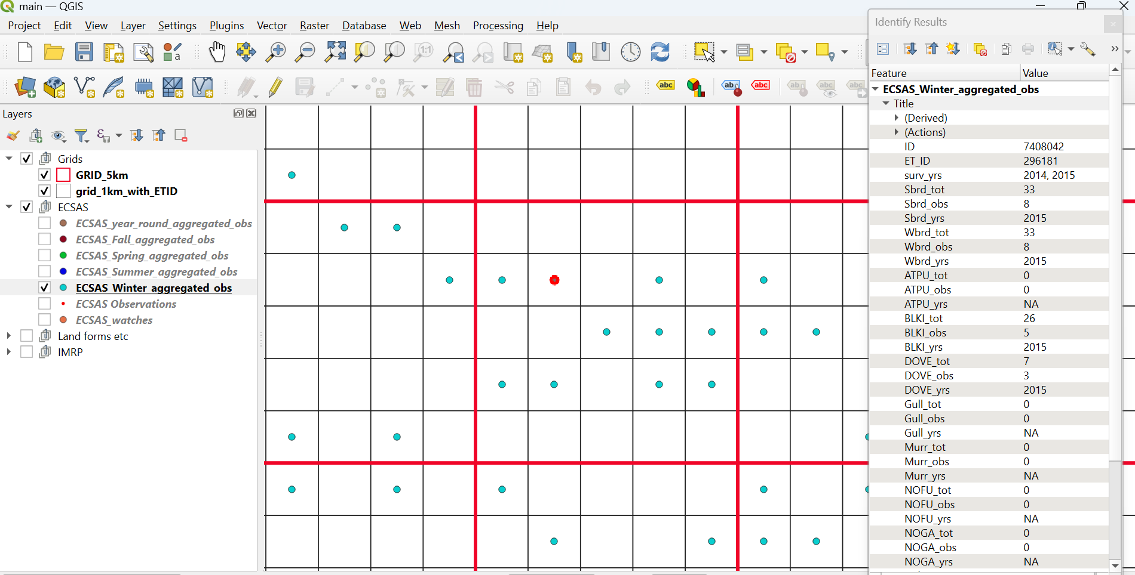
Figure 1. Screenshot from QGIS showing the first 30 columns for a given data point highlighted in red (on the Labrador Shelf during winter). This cell has ID 7408042 in the 1 km grid (black squares), and is contained within cell 296181 of the 5 km grid (red squares). It had survey effort in 2014 and 2015 (surv_yrs), during which a total of 33 seabirds (Sbrd_tot) were detected in 8 observed flocks (Sbrd_obs), during years 2015 (Sbrd_yrs). Given that the numbers for the Sbrd and Wbrd taxa are identical, this indicates that there were no waterfowl observed in addition to the seabirds. The figure shows that there were 26 BLKI observed in 5 observations, and 7 DOVE in 3 observations during 2015 and no observations of other species (not all shown in figure). There were no observations during 2014.

AUSH = Audubon’s Shearwater, BASH = Balearic Shearwater, COSH = Cory’s Shearwater, TOSH = Townsend’s Shearwater, and YESH = Yelkouan Shearwater.

